(**This is not the actual application; use this template for planning purposes only**)

This document provides the data fields and presents the general format of our online grant application. Please use this template only to organize information before completing and submitting the online application. This document cannot be submitted as an application. The official application is available online at https://sdac.gosmart.org.

Program Description
program provides grants to host teaching artists (from the SDAC roster) in schools and other South Dakota nonprofit organizations. The program encourages and supplements the arts in educational settings and fosters community development through life-long learning experiences in the arts.

Teaching artists are an invaluable resource for schools and communities and greatly contribute to the overall process of learning. Ways in which teaching artists intersect with schools and community-based organizations may include:
- Short and long-term in-school and after-school residencies.
- Arts integration instruction that supports higher order thinking skills in which students learn math, science, language arts and social studies through visual art, music, dance and/or theatre.
- Curriculum-based projects using K-12 arts and non-arts education standards.
- Core arts instruction in visual art, dance, theatre, and/or music.
- Professional development for educators.
- Lifelong learning in the arts through community events, classes and workshops.

Eligibility Requirements
- Artists who live and work in South Dakota, Indigenous artists, and artists who live in bordering states are given priority.
- Professional artists are encouraged to apply. The South Dakota Arts Council defines professional artists as individuals who earn 50% or more of their income from their artistic work.

The following individuals are NOT ELIGIBLE to apply:
- Students pursuing a high school diploma, undergraduate or graduate degrees
- South Dakota Arts Council current board members, staff, and grant review panelists.

General Instructions
As you work through the application, click the “SAVE WORK” button at the bottom of each application page before proceeding. You can continue working through the application at any time.

Be sure to review the AISC Guide to Grants for Artists in the Applicant Portal BEFORE YOU BEGIN online at https://artscouncil.sd.gov/grants/AISC_Guide_Artists.pdf

If you have questions about the AISC program, including whether or not you need to apply after having served as an artist on the AISC roster, please contact program coordinator Rebecca Cruse, rebecca.cruse@state.sd.us, 605-295-4052.

If you have questions, contact the South Dakota Arts Council (605-773-3301). Staff is on-hand to assist applicants during business hours, 8:00 a.m. - 5:00 p.m. Central, Monday through Friday.

ARTIST INFORMATION
As you work through the application, click the “SAVE WORK” button at the bottom of each application page before proceeding. You can continue working through the application at any time.

If you have questions, contact the South Dakota Arts Council (605-773-3301). Staff is on-hand to assist applicants during business hours, 8:00 a.m. - 5:00 p.m. Central, Monday through Friday.
* Professional Artist Résumé: Upload a single document, 5 pages or less, highlighting recent activity and a record of achievement in the arts. Keep in mind, panelists evaluate the applicant’s record of professional activity and achievement. Before uploading, convert your document to a PDF if possible. | upload file (REQUIRED)
* Eligibility: Do you meet the eligibility requirements for this grant category and is your application in line with what this grant category may fund? If so, check the box to confirm. | - By checking this box, I agree that I have read, understand, and agree to this statement.
* Artist's Status: Are you a student at the time of application? Students pursuing high school diplomas and graduate, or undergraduate degrees are not eligible. Check the box to indicate that you ARE NOT a student at the time of application. | - No, I am not a student.

NARRATIVE
Narrative: Upload a single document, 5 pages or less, addressing the questions provided:

Artistic Capacity: Provide a brief history and vision of your work as an individual artist. What steps do you take to stay current as an artist?
Teaching Capacity: Why do you want to be a teaching artist? How have you prepared yourself for the role of teaching artist? Describe your experiences working with students, schools and/or community arts programs.
Residency Planning: Describe one idea or project that you might offer to a school for a residency. Address the following:
- State the overall goal of your residency work. What do you want students and teachers to know and be able to do once a residency has been completed?
- Describe the main steps you will take to implement your residency plan. What will happen at the beginning, middle, and end?
- Artists in Schools & Communities Guidelines require the teaching artist to work with a designated core group of students each day of the residency with the intent of providing an in-depth experience. This often consists of one specific grade-level or small group of students. Describe how you might deepen or extend your described project to provide an in-depth experience for the core group of students?
- During your residency, you may also have time to meet with students not included in the core group. For this group of students, you will be asked to provide an abbreviated lesson or exposure to your art form. Describe how you might adjust/modify the above described residency project to fit the needs of the non-core students.
- Does your residency help teachers meet any of the Fine Arts Content Standards or integrate the arts with other content areas? If so, describe how. (online at https://doe.sd.gov/contentstandards/documents/SD-FA-standards.pdf)
- How will you incorporate reflection in the described residency and emphasize its importance in the learning process?
Teacher/Artist Involvement: Involving teachers and Administrators in your residency plan is essential to overall success. Describe what steps you will take to engage these key players in your residency plan. Consider the following:
- How will you foster communication and collaboration in the planning prior to the residency?
- What information and resources will you share with teachers and/or students prior to your residency to foster excitement as they prepare for your visit?
- What information and resources will you leave upon completion of your residency to extend the learning for both students and teachers?
Community Engagement: Engaging the community (students, teachers, school-board members, parents, and others) during the residency provides a platform for sharing your art and student work. In addition, it provides an opportunity for the community to discover the value of partnerships in arts education. It is a good idea and often requested to include some form of performance or presentation to the community (parents, other teachers, students, community members, etc.) at the end of the residency. Describe your ideas for this community event.

As you work through the application, click the “SAVE WORK” button at the bottom of each application page before proceeding. You can continue working through the application at any time.

Be sure to review the AISC Guide to Grants for Artists in the Applicant Portal BEFORE YOU BEGIN online at https://artscouncil.sd.gov/grants/AISC_Guide_Artists.pdf

If you have questions about the AISC program, including whether or not you need to apply after having served as an artist on the AISC roster, please contact program coordinator Rebecca Cruse, rebecca.cruse@state.sd.us, 605-295-4052.

If you have questions, contact the South Dakota Arts Council (605-773-3301). Staff is on-hand to assist applicants during business hours, 8:00 a.m. - 5:00 p.m. Central, Monday through Friday.

Program Description
Artists In Schools & Communities (AISC) program provides grants to host roster artists in schools and other South Dakota nonprofit organizations. The program encourages and supplements the arts in educational settings and fosters community development through life-long learning experiences in the arts.
* Narrative: Upload a single document, 5 pages or less, addressing the questions provided. Keep in mind, panelists evaluate and score based on an applicant’s responses. Before uploading, convert your document to a PDF if possible. | upload file

RESIDENCY PLAN
Residency Plan (REQUIRED): Upload a single document, 3 pages or less, including objectives, sequential activities, and a supply list with approximate costs. If applicable, include outlines demonstrating appropriate activities planned for different age levels, i.e., elementary, middle school, high school, adult learners, etc.

As you work through the application, click the “SAVE WORK” button at the bottom of each application page before proceeding. You can continue working through the application at any time.

Be sure to review the AISC Guide to Grants for Artists in the Applicant Portal BEFORE YOU BEGIN online at https://artscouncil.sd.gov/grants/AISC_Guide_Artists.pdf

If you have questions about the AISC program, including whether or not you need to apply after having served as an artist on the AISC roster, please contact program coordinator Rebecca Cruse, rebecca.cruse@state.sd.us, 605-295-4052.

If you have questions, contact the South Dakota Arts Council (605-773-3301). Staff is on-hand to assist applicants during business hours, 8:00 a.m. - 5:00 p.m. Central, Monday through Friday.

Program Description
Artists In Schools & Communities (AISC) program provides grants to host roster artists in schools and other South Dakota nonprofit organizations. The program encourages and supplements the arts in educational settings and fosters community development through life-long learning experiences in the arts.
* Residency Plan: Upload a single document, 3 pages or less, including the information requested. Keep in mind, panelists evaluate and score based on an applicant’s responses. Before uploading, convert your document to a PDF if possible. | upload file

REFERENCES & LETTERS OF SUPPORT
References and Letters of Support (REQUIRED):
References and letters of support should relate to the work included in your application. Materials should demonstrate the applicant’s artistic excellence and merit. Keep in mind, panelists evaluate, and score based on the materials provided.

Be sure to review the AISC Guide to Grants for Artists in the Applicant Portal BEFORE YOU BEGIN online at https://artscouncil.sd.gov/grants/AISC_Guide_Artists.pdf

If you have questions about the AISC program, including whether or not you need to apply after having served as an artist on the AISC roster, please contact program coordinator Rebecca Cruse, Rebecca.cruse@state.sd.us, 605-295-4052.

If you have questions, contact the South Dakota Arts Council (605-773-3301). Staff is on-hand to assist applicants during business hours, 8:00 a.m. - 5:00 p.m. Central, Monday through Friday.

Program Description
Artists In Schools & Communities (AISC) program provides grants to host roster artists in schools and other South Dakota nonprofit organizations. The program encourages and supplements the arts in educational settings and fosters community development through life-long learning experiences in the arts.
References  *Provide three references with email addresses and phone numbers in the space provided. | (REQUIRED Must be typed in the space provided. 1000 characters.)
*Letters of Support: Applicants may upload PDF copies of letters signed by the letter writer and endorsing your work as a teaching artist. (no more than 3 documents/10 pages total). Submit at least 1 and up to 3 support documents. Before uploading, convert your document to a PDF if possible. | upload file (REQUIRED)  upload file  upload file

WORK SAMPLES
Attach Work Samples (REQUIRED):
Use this SECTION to attach work samples to the application located in your MEDIA LIBRARY. Be sure to attach your best work to the application.
Use the MEDIA LIBRARY tab to upload and manage your media files. [Please Note: The MEDIA LIBRARY is not your application. Applicants must select work samples from the MEDIA LIBRARY to attach to the application.]
Applicants must demonstrate quality within the art form (by the applicant(s) or artist(s) involved in the work of an organization). Grant panels review artist/artistic quality and consider this in all funding recommendations for grants.
All applicants MUST provide samples of their work and/or examples of the work they plan to do for review. Keep in mind, panelists review only the work applicants submit.
Learn more about that page and how to use the MEDIA LIBRARY by watching this video [linked here].
Direct Links Document: Applicants may attach a document of direct links to work samples (no more than 10 links total). This may include direct links to work samples on Vimeo, Spotlightr, YouTube, TikTok or other media platforms. Be certain content does not require a password or present other barriers to easy access. Please provide a short description of the media (such as video of educational outreach/programming, video of live performances/presentations, photos of events, publicity articles of events or programs, etc.) followed by the associated hyperlink.

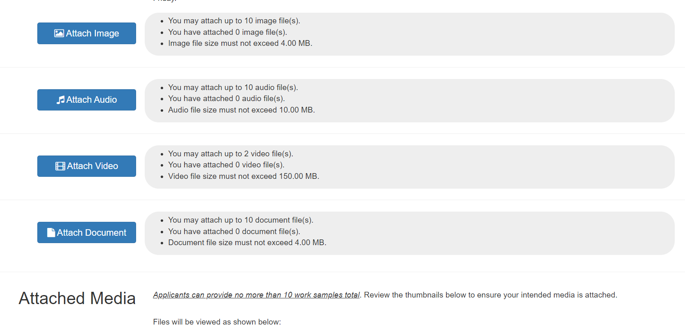

APPLICANT ASSURANCES
Before you submit your application, review the entire application and then print/save a copy of the PDF for your records. Once you submit your application you will not be able to make changes. In checking these boxes, adding your (first and last) initials, and providing the date of your agreement, you certify that that you have read, understand, and agree to these statements.

DO NOT MAIL this page or any section of your application to the South Dakota Arts Council.
* Applicant Certification: I certify that I meet the eligibility requirements. I confirm that my application is in line with what this grant category may fund. I certify that the application information is true and complete to the best of my knowledge. I understand and agree that any funds granted as a result of this application are to be used for the purposes set forth herein. | - By checking this box, I agree that I have read, understand, and agree to this statement.
* Authorized Individual Certification: I certify that I am the individual authorized to commit the applicant to abide by all relevant Terms and Conditions. In addition, I give the SDAC permission to duplicate submitted documentation for use in the grant review process. | - By checking this box, I agree that I have read, understand, and agree to this statement.
* Initials of authorized individual (applicant) | (first and last initials only)
* Date of submitted application (serves as date of agreement to above statements) | (MM/DD/YYYY)

